Tiled

Download Tile Sets from <http://opengameart.org/> or somewhere else   
(16x16 or 32x32 or 48x48 {if48x48 Slice it to 16x16})

Download Tiled from my.xmarks.com

Start a new File 16x16, drag the Tile Set and choose Tiles wide 16x16.

In Tiled make only the Map do not us details like barrels or logs (or you will have a lot of extra work to do in unity with the colliders)

Before you save it change the map size that you don’t have some empty tiles (important for unity scale)

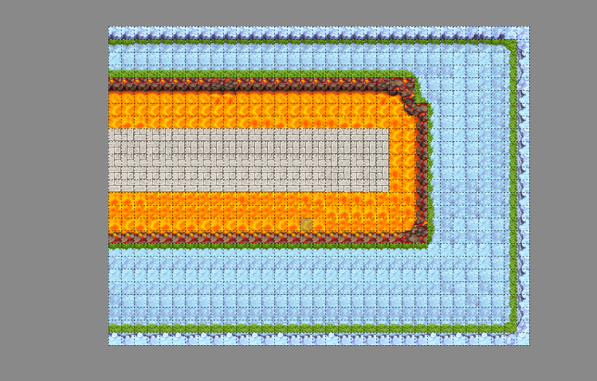This is good

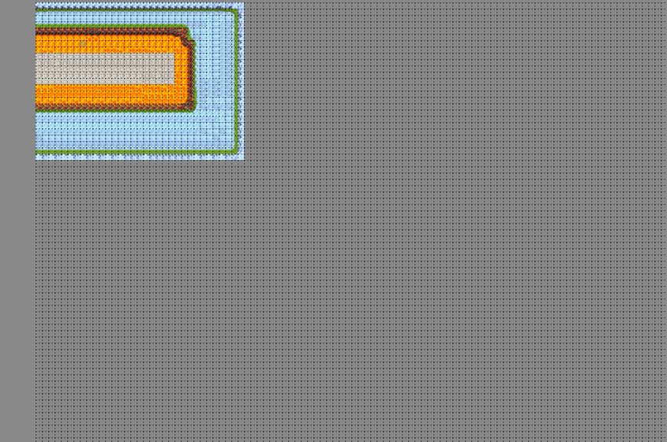This is bad

Unity

Drag the Finished map into your unity folder (C:\Zaim\FunsDorf\Game\Funsdorf_Project\Assets\Game_Stuff\Textures\Environment\World)

Drag it now into your unity world and scale it up to 4 or 5 (depends on how big or small you want it {don’t scale it too big or you will have only pixels...})

Details:

Drag the Tile Set into you unity folder  
(C:\Zaim\FunsDorf\Game\Funsdorf_Project\Assets\Game_Stuff\Textures\Tiles)

Choose in the inspector Sprite Mode Multiple (instead of Single).  
Open up the Sprite Editor. Press Slice >> Type >> Grid by Cell Size >>Pixel Size X 32 Y 32

Choose your item what you need. Rename it to a what it looks like (Barrel should be name as Barrel not as stuff_1) use the ending _Tile Example: Barrel_Tile  
Apply it and drag your barrel into your world . Use now a box Collider or what Collider you need. You can also add now the script (if you made one. If not add it later to the Prefab) drag the finished object now to the Prefab folder.

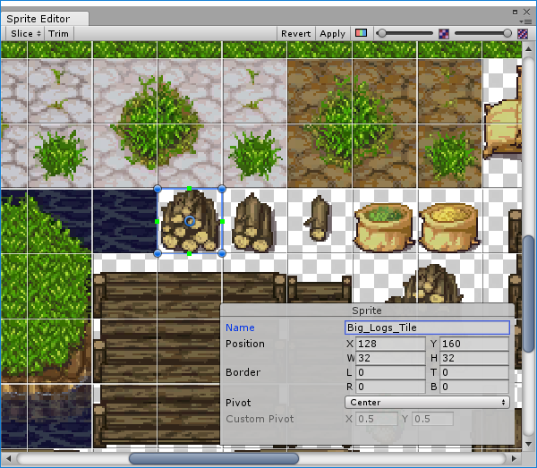Now you can you this prefab when every you need it and it will have every time the collider and the scripts. If you need to change something change the components on the object inside of the prefab folder so you don’t need to change it on every object in your world.